Name: inapakurthi kiran kumar

Mail: kiraninapakurthi123@gmali.com

Batch: Vcube-125(10AM)

GitHUB: <https://github.com/kiran1417561>

**Task on Connect S3 Bucket To Instance By Using “IAM”:**

* First create S3 Bucket .
* Now go to IAM role then,create a role.
* Go to EC2 create an instance .

**Now we have to attach instance to IAM Role :**

* Go to instance selete our instance ->Actions ->Security ->Modify IAM Role.
* Now connect to server then go to root user .

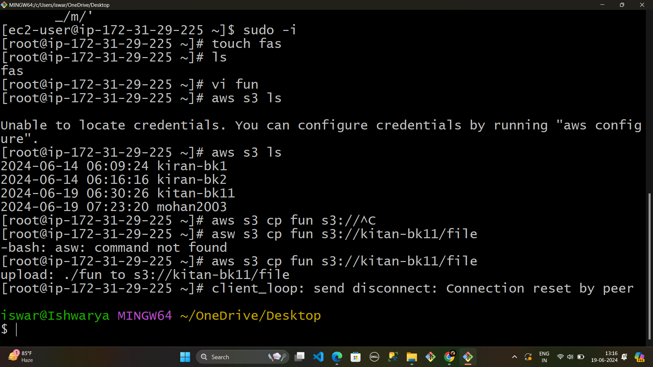

* Through the commands we can cp the files .
* That aws s3 cp s3://bucket name/file name(new file).
* Then it show file to s3 .

**By this we can connect the s3 bucket to instance by using IAM Role.**

